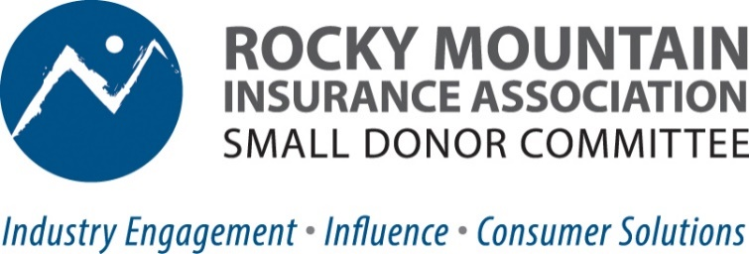

Why should Colorado insurance professionals care about state politics? “My company takes care of all of our political and lobbying positions, why would I need to pay attention to what happens at the Colorado State Capitol.” We often hear that, but unfortunately, lawmakers are paying attention to YOU. Critical decisions are currently being made with little insurance knowledge, and lawmakers are proposing legislative “solutions” that would mandate how policies are sold, quoted, and priced, impacting ALL insurance professionals. Understanding the legislative environment also positions us to engage proactively, rather than reactively, and strengthens our credibility as industry leaders.
So, how can we make a difference? Together is the answer. We need to invest in the insurance industry’s political clout by joining the Rocky Mountain Insurance Association’s Small Donor Committee. Here’s how it works:
- $50 contribution per year by you translates into support for candidates up to $5350 State Legislative Candidates, $12,250 Statewide Candidates. Pooling small donations from the P & C insurance industry to back business-friendly candidates who understand and support our issues.
- Join the RMIA Small Donor Committee today through RMIA’s secure online payment system. (Maximum Annual Contribution is $50)
  - Sign Up Options:
    - Via RMIA website: Property & Casualty Insurance Resources for Agents (rmiia.org)
    - Via QR Code Checkout:


Why a Small Donor Committee? It’s vital to support BOTH Political Action Committees (PAC) AND SDCs. A SDC is a political contribution utilized by industries like ours with large numbers of potential donors, like teachers, unions, lawyers who donate a small amount and the law then allows for larger contributions to candidates. Elected officials also view SDC contributions as support from “the little guy” and united individual influencers. A united insurance industry led by agents is the most powerful.

ACTION NEEDED NOW!
Colorado’s challenged property insurance market is the target of 2025 legislation that has the potential to topple the market with added costs, rate/non-renewal mandates and consumer reporting requirements that have consequences to your business and customers.

Now is the time to engage and get active!

The Rocky Mountain Insurance Association Small Donor Committee is a bi-partisan organization that works to elect candidates who support the insurance industry’s efforts to preserve Colorado’s stable, competitive property and casualty insurance marketplace & tort environment. For more information contact: Jurree Scherrer, Operations Director, RMIA 303-790-0216 / jurree@rmiia.org.

